1mil city benchmarks + details

Init point = (116.20287663548845, 39.75112986803514)

MR size = 434556

Filtering parameter = 0,0001 \* |MR|

RSK size = 6991

With candidates:

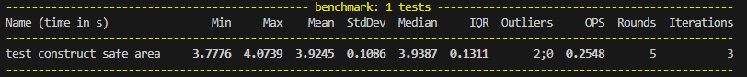With Route skeleton:

